 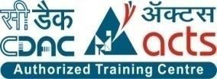

INSTITUTE FOR ADVANCED COMPUTING AND SOFTWARE DEVELOPMENT AKURDI, PUNE

Documentation On

**“EMPLOYEE MANAGEMENT SYSTEM”**

PG-DAC Mar 2022

*Submitted By:*

**Group No: 33**

**Dayal Chimnani**

**223044**

**Himanshu Mandiya**

**223070**

**Prashant Karhal Miss.Megha S. Mane**

**Centre Coordinator Project Guide**

# Table of Contents

1. Introduction 1

Document Purpose 2

Problem Statement 2

Product Scope 2

Aim & Objectives 2

1. Overall Description 3

Product Perspective 3

Benefits of Society Management System 3

User and Characteristics 3

Operating Environment 3

Design and Implementation Constraints 3

1. Requirements Specification 4

External Interface Requirements 4

3.3 Non-Functional Requirements 12

1. System Diagram 11

Activity Diagram 11

Data Flow Diagram 13

Class Diagram 15

Use Case Diagram 16

ER Diagram 16

1. Table Structure 17

Flat owners 17

Notices 17

Complaints 17

Visitors 18

Bill 18

Workers 18

1. Conclusion 19

Future Scope 19

1. References 20

**List of Figures**

Figure 1 Admin Activity Diagram 11

Figure 2 Flat Owner Activity Diagram 12

Figure 3 Watchman Activity Diagram 12

Figure 4 Level 0 Data Flow Diagram 13

Figure 5 Level 1 Data Flow Diagram 13

Figure 6 Level 2 Data Flow Diagram for Admin 14

Figure 7 Level 2 Data Flow Diagram for Flat Owner 14

Figure 8 Level 2 Data Flow Diagram for Watchman 15

Figure 9 Class Diagram 15

Figure 10 Use Case Diagram 16

Figure 11 ER Diagram 16

# Introduction

An employee management system is a software, that helps your employees to give their best efforts every day to achieve the goals of your organization. It guides and manages employee’s efforts in the right direction. It also securely stores and manages personal and other work-related details for your employees. In the employee management system, you can manage admin activities in an easier and quicker way. Employees are an important part of your organization it is their work that ultimately contributes to the bottom line of the company. It is an important part of HR management. It also helps to employee engagement and employee retention brings down costs and increases productivity.

## 

## Document Purpose

[Employee self-service portals](https://www3.technologyevaluation.com/sd/category/employee-management/Features/self-service-portal), or ESS portals, are typically available in modern employee management suites. These portals enable employees to take care of a variety of human resources-related issues that may have otherwise needed to be taken care of by an HR employee. Most self-service portals let employees update personal information, such as contact information, address, and bank account information. In addition, some employee self-service portals enable employees to correspond directly and securely with the human resources department outside of office hours, which saves time and creates a written record of communications.

## Problem Statement

Employee management system is a system developed with an aim to solve the problem faced by organizations while calculating salary of each employee. This system aims to maintain proper automatic attendance so that no cheating in attendance can be done by any one. This system makes sure that all the important calculations should be done to calculate salary properly. EMS promotes automatic use and ensures employees that their salary would be calculated properly without any cheating. Proper holidays, week offs and festival holidays granted by organizations are kept for each employee. It provides flexibility of choosing different days off for different employees and accordingly salary would be calculated at the end of month, because of this feature salary may vary according to week days off given to employees if varying week offs.

## Product Scope

* Employee Management System is a distributed application, developed to maintain the details of employees working in any organization. It maintains the information about the personal details of their employees, also the details about the payroll system which enable to generate the pay slip.
* J2EE Technology used for the development of the application.
* General Employee as well as the admin staff will be able to use the system effectively.
* Web-platform means that the system will be available for access 24/7 except when there is a temporary server issue which is expected to be minimal.

## Aims & Objectives

Specific goals are: -

* To produce a web-based system that allow the admin to add employee and provide functionalities to its role.
* Designing a scheduling system for a work centre. Scheduling is such a tool with which the process of intimating activities and notifications will be easy and even online in the organization where it is installed.

# Overall Description

## Product Perspective:

2.1.1 Existing system function:

In the present Employee Management System of data management, some person maintains the data manually, which required a high amount of time as there are so many people work in the organization. The organization keeps the record of all the employees in the paper which is not a secure way of maintaining the data. As there is a high amount of register in which information is stored consume a lot of space in the organization while retrieving any information from that many files consume huge time and it is not an easy process.

* **III. PROPOSED SYSTEM**

This Employee Management System project will help the organization with the management of the information of the employees. The system will centralize the management system and will provide different options through access to data will become accessible. The system will be based on the internet so that any user can use it from any place with ease. The Employee Management System software will make a report of each employee of the organization at the end of the month so that the organization will have information about the work of each employee. This Employee Management System will not only reduce the time but as

Well it will make the system efficient

## Benefits of Employee Management System

* This system will reduce the complexity of employee management.
* By using this system, we can easily maintain all the records about” ON EMPLOYEES” or “OFF EMPLOYEES”.
* It will reduce searching time.
* It can be easily handled by the person who have elementary know
* ledge of computer because it provides auser-friendly environment.
* It’s hardware and software configuration are not very costly that means
* The hardware and software requirement for this soft
* ware/project are not very costly.

## Users and Characteristics:

Admin:

* Admin can login to the system.
* View the list of Employee in the company.
* Add new Employee.
* Delete Employee.
* Update Employee.
* Accept and rejected the request of Employee.
* Circulate notice among all the flat owners.
* Add workers in the society.
* View workers working in the society.

Employee:

* + Employee can login to the system.
  + View his/her details.
  + View notification.
  + Generate pay slip.
  + Update their personal credentials.
  + Apply the leave.

## 

## Operating Environment:

Server Side:

**Processor:** Intel® Xeon® processor 3500 series

**HDD:** Minimum 500GB Disk Space

**RAM:** Minimum 8GB **OS:** Windows 10, Linux 6 **Database:** My-Sql

Client Side (minimum requirement):

**Processor:** Intel Dual Core

**HDD:** Minimum 80GB Disk Space

**RAM:** Minimum 8GB

**OS:** Windows 10, Linux

## Design and Implementation Constraints:

* The application will use Ajax, JavaScript, jQuery and css as main web technologies.
* HTTP and FTP protocols are used as communication protocols. FTP is used to upload the web application in live domain and the client can access it via HTTP protocol.
* Several types of validations make this web application a secured one and SQL Injections can also be prevented.
* Since Employee Management system is a web-based application, internet connection must be established.
* The Employee Management System will be used on PCs and will function via internet or intranet in any web browser.

# Specific Requirement

## External Interface Requirements:

User Interfaces:

* + All the users will see the same page when they enter in this website. This page asks the users a username and a password.
  + After being authenticated by correct username and password, user will be redirect to their corresponding profile where they can do various activities.
  + The user interface will be simple and consistence, using terminology commonly understood by intended users of the system. The system will have simple interface, consistence with standard interface, to eliminate need for user training of infrequent users.

Hardware Interfaces:

* + No extra hardware interfaces are needed.
  + The system will use the standard hardware and data communication resources.
  + This includes, but not limited to, general network connection at the server/hosting site, network server and network management tools.

Application Interfaces:

**OS:** Windows 10, Linux

**Web Browser:**

The system is a web-based application; clients need a modern web browser such as Mozilla Firebox, Internet Explorer, Opera, and Chrome. The computer must have an Internet connection in order to be able to access the system.

Communications Interfaces:

* + This system uses communication resources which includes but not limited to, HTTP protocol for communication with the web browser and web server and TCP/IP network protocol with HTTP protocol.
  + This application will communicate with the database that holds all the booking information. Users can contact with server side through HTTP protocol by means of a function that is called HTTP Service. This function allows the application to use the data retrieved by server to fulfil the request fired by the user.

# System Design

## Activity Diagram

## activity-Admin.jpg

**Figure 1: Admin Activity Diagram**

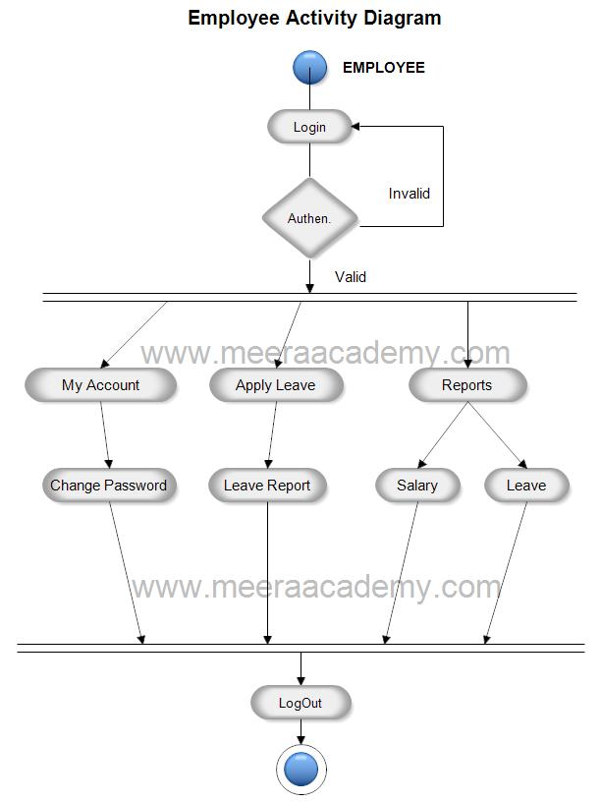

**Figure 2: Employee Activity Diagram**

## 

## Data Flow Diagram

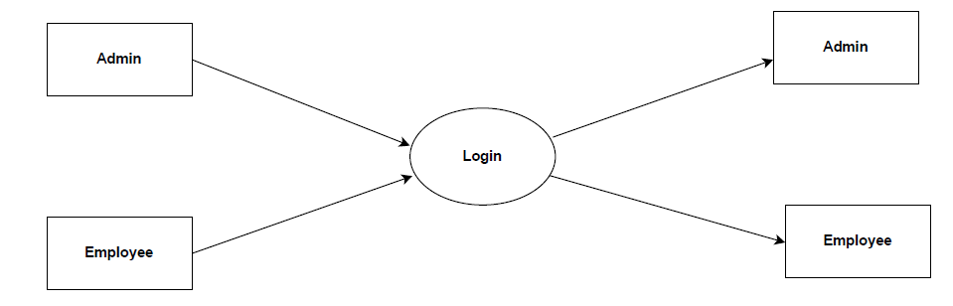

**Figure 4: Level 0 Data Flow Diagram**

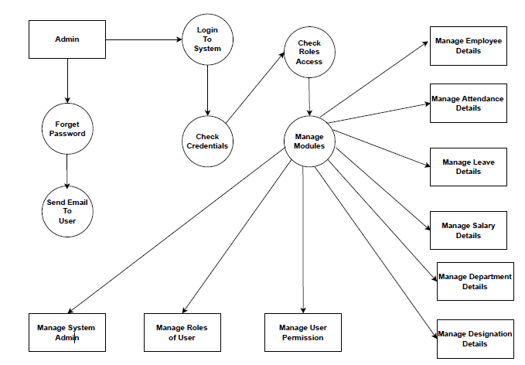

**Figure 5: Level 1 Data Flow Diagram**

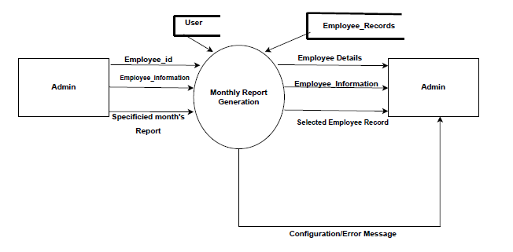

**Figure 6: Level 2 Data Flow Diagram for Admin**

## 

## ER Diagram

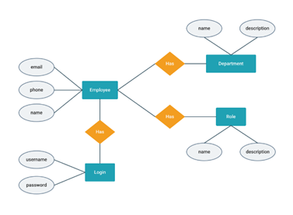

**Figure 11: ER Diagram**

# Table Structure

## Employee Management System

## 

# Conclusion

It is essential for you to know the used to design and develop the Employee Management System. That is because you cannot perfectly create a fully-functional system without it. But if you create this diagram, you will know the possible inputs and scenarios that the system should process and perform. Not only that, you will find out the needed processes and connect them to the other UML Diagrams.

# Future Scope

This project can be enhanced further by adding club house booking, online voting system, online payment facility for the members to reduce the extra work of the admin. The software is flexible enough to be modified and implemented as per future requirements. We have tried our best to present this free and user–friendly website to Society members. Message and Email alerts for various happenings in the society can be added to the system so that users do not miss the updates and happenings of the society.

# 7.0 References

[1] – Begg Carolyn, Connolly Thomas, Database systems (a Practical approach to Design, Implementation, and Management), Addison-Wesley, an imprint of Pearson Education, University of Paisley (U.K.), Fourth edition 2005

[2] – Bodnar George /Duquesne University/, Hopwood William /Florida Atlantic University/, Accounting Information systems, Eighth Edition, Prentice Hall, Upper Saddle River, New Jersey .

[3] – Andersen Virginia, Access 2000: The Complete Reference, Blacklick, OH, USA: McGraw-Hill Professional Book Group, 2001, http://site.ebrary.com/lib/vaxjo/Doc?id=5002842 (2006-05-25).

[4] – Andersson Tobias, [DAB744] C# Course Lectures, School of Mathematics and System Engineering, Växjö University. [5] - http://msdn.microsoft.com/library/default.asp?url=/library/en- us/vbcon/html/vboritextboxctltasks.asp (2006-05-25)